ORDER FORM

Order No.: Name of Customer: Date: ____
Hair Type: % Brazilian Human Hair Malaysian virgin Chinese virgin Indian remy
Hair Texture & Curl: ___ _______ [ ] As picture
Hair Length:
Hair Color: _ __ [ ] As picture
Hair Density: [ ] 120% [ ] 130% [ ] 150% [ ] 180% [ ] Other
Baby Hair: [ ] Around Entire Perimeter [ ]Front [ ] Back [ ]none
Type of Knots: [ ] General Knots [ x ] Bleached Knots
Hair Style: [ ] Free Style [ ] Right part [ ] Left part

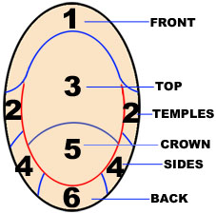  If you are getting high-lights please let me know the area that you want each color | Cap Design:  1.[ ] Lace Front Wigs(lace handtied in front, weft hair in the back) (CLB -CAP-03)  2.[ ] Full lace wigs  2-1[ ] With a little Stretch Lace From ear to ear ( CLB-CAP-01)  2-2[ ] With lace in front,stretch lace in the back (CLB -CAP-02)  2-3[ ] Without Stretch Lace.( CLB -CAP-04)  3.[ ] Glueless cap.( CLB -CAP-05)  4.[ ] thin skin around perimeter，lace around the head, with a little stretch lace from ear to ear (CLB-CAP-06)  5.[ ] customized  Lace Color: [ ] dark brown [ ] brown [ ] light Brown  [] light(transparent)  Silk base color(if have): [ ] dark brown [ ] brown  [ ] light Brown [] light(transparent)  Lace Type: [x] Swiss [ ] French
Cap Size
[ ] Large [ ] Medium [ ] Small [x] Customized
Head Measurement Template

1 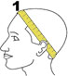 Circumference 2 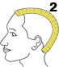 Front to Nape
3 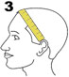 Ear to ear across forehead 4 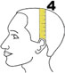 Ear to ear over top
5 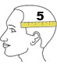 Temple to temple round back 6 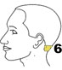 Nape of Neck

Size: 1 2 3 4 5 6 ____

Friendship Reminding:
Please make sure that you make your head measurement in this way shown in the above pictures. Right measurement is very important for us to make right wig for you. If the measurement is not right, the lace wig will not work well because we will exactly make the wig according to your measurement size.
In case of wrong measurement you give us,We are not responsible for unsuitable wig.
Special Instruction

